Historical Officers Report
From the Pages of the Camden Advertiser

October 1942
1st October
Land Army Girls at Menangle Park.
FIRST of the Land Army girls have arrived at Menangle Park, where they are employed picking peas on Mr. Hawkey's property.
Care of Tyres Saves Rubber. The greater mileage from each tyre the less the demand for new tyres and the greater the saving of raw rubber. Unless we conserve rubber to the utmost extent possible, we may reach the stage when rubber tyres will no longer be available," advises the Department of Supply to motorists to "keep the home tyres turning," Drivers should take care that tyres are interchanged at proper intervals and make sure that the spare is used. Wheel alignments should be checked frequently. Tyres should not be allowed to come into contact with oil or grease as they soften the rubber and accelerates tyre wear.
Promoted to Brigadier. The highest-ranked local district serviceman in the present war is Brigadier Denzil Macarthur Onslow, D.S.O. He was a major early in 1941 when he was awarded the Distinguished Service Order and promoted, to lieutenantcolonel for his gallantry and dashing leadership against the Italians in the first Libyan campaign. For his daring work on later occasions he was again mentioned in despatches. His army number is NX135. He attained the rank of brigadier soon after his return to Australia from the Middle East earlier this year. Denzel’s younger brothers are also serving: Edward is a lieutenant-colonel commanding an A.I.F. machine-gun battalion in the Middle East, while Andrew holds the rank of flying-officer in the R.A.A.F.
8th October 25 Bde contacted Japanese rear guard at Templeton's Crossing
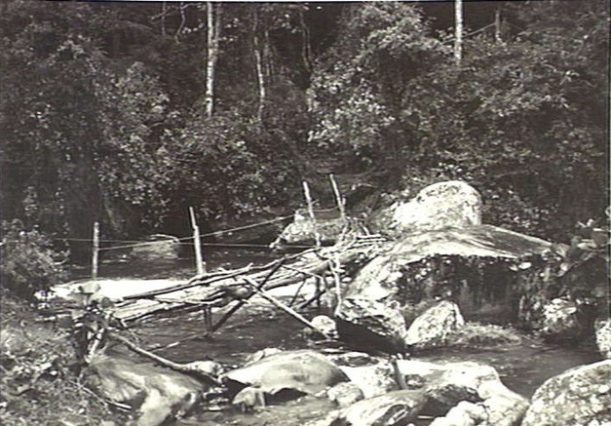

Land Girls' Good Work At Menangle Park. Progress reports of Land Army Girls employed at Menangle Park are most encouraging, states our representative in that centre. Although only one girl has had previous experience they have proved their ability at pea picking. Daylight saving has proved most unsatisfactory to all sections of this community. Some farmers, with, stock to handle, cannot adhere to the altered times.
SUNDAY'S WINDSTORM FIRE DESTROYED HOME AT ORANGEVILLE Fanned by a particularly severe windstorm, fire completely destroyed the home of Mr. and Mrs. C. R. Dunk at Orangeville early on Sunday afternoon. Mr. and Mrs. Dunk were visiting their son (Paul), who is seriously ill in Camden District Hospital, at the time. Relatives and neighbours rushed to the cottage but the intense heat prevented them from saving any of the furniture or other household effects, the property and contents were uninsured.
BUILDING UNROOFED. Many buildings were damaged throughout this district by the wind which continued for nine hours. The side of o cottage was wrecked at Narellan. - The main heavy iron roofing from the upper-storey of D. F. Maloney’s drapery shop in Argyle-street, Camden, was caught by the storm's fury 5 o'clock and deposited in the centre of the main street. Roofing and trees were blown down in other local centres. In some cases these fouled telephone wires and interrupted the services.
RECORD HEAT WAVE. At 1 p.m. on Sunday the temperature was 101 degrees—probably a record for this time of the year. A striking contrast was experienced on Monday night when the temperature dropped by 48 degrees.
15th October. 25 Bde drove Japanese back from Templeton's Crossing
TOYS FROM JAP. ZEROS CAMDEN SOLDIER'S UNIQUE SOUVENIRS. Japanese zero fighter-planes, shot down near Moresby, provided the material for a set of toys for young David Butler, of Broughton-street, Camden. The pieces of aluminium were neatly cut and cleverly designed into toy dogs, cats, ducks, fish, stock, kangaroo and a penguin, by David's father —Sapper Gordon Butler. The penguin formed the badge of Sapper Butler's unit.
GERMAN TANKS SMASHED LOCAL LADS HELPED TO STOP ROMMEL IN EGYPT
Jerry turned it on pretty hot . . . he attacked us time and time again, but each time he failed to break through and there were knocked-out German tanks lying everywhere . . . One tank passed within 3 or 4 feet of me." Writing to his sister (Mrs. A. Barber), Private Owen Smart, of Cawdor, vividly described his A.I.F, machinegun battalion's first face-to-face action with the enemy in Egypt. For sixteen hours on July 10 last the Germans raked the Australian position with constant shell-fire and added machine-gun bursts and a drive by tanks in desperate efforts to break through the A.I.F. barrier guarding the route to Egypt's capital. It was during this period of hellfighting that Sergeant A. W. (Gus.) Longhurst, of Campbell town, won the Military Medal. Private Smart reported that his sergeant deserved the decoration.
22nd October 9th Aust Div prepared to attack Rommel's forces at El Alamein, North Africa
23rd October Second battle El Alamein begins
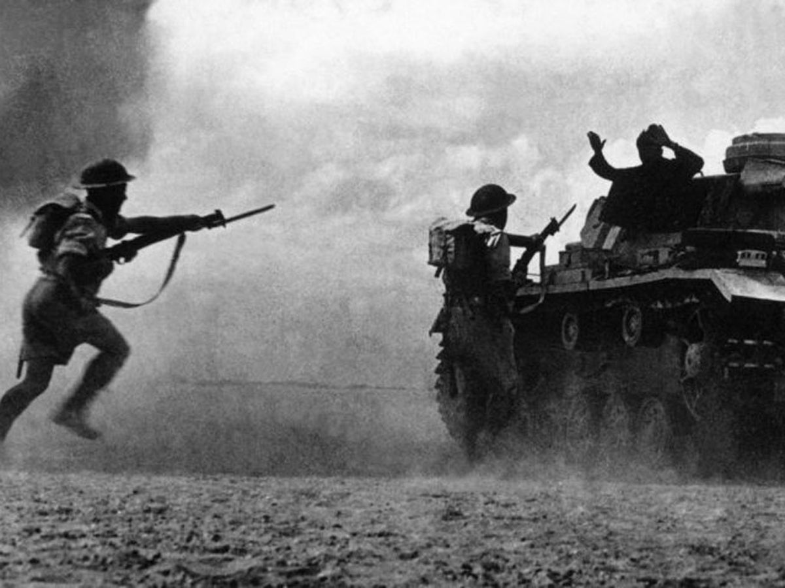
24th October Eora Creek, Kokoda Trail
26th October Pte Percy E. Gratwick VC at Miteirya Ridge, Western Desert
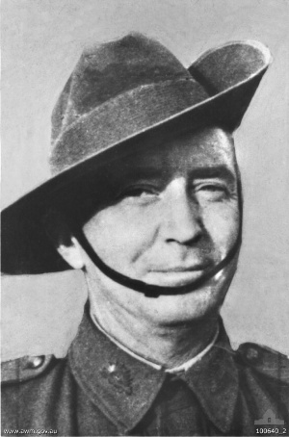
31st October Sgt William Henry Kibby VC at El Alamein
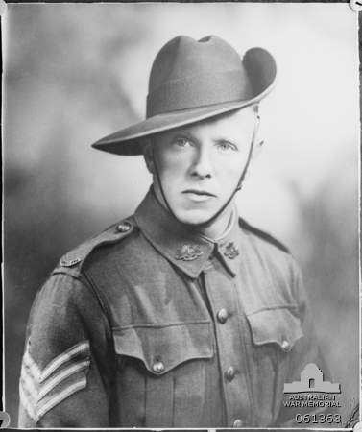

Ray Herbert Historical Officer Camden RSL Sub Branch

