Historical Officers Report
From the Pages of the Camden Advertiser
September 1943
2nd September CORP. COLIN DENGATE Another local soldier previously listed as missing and now officially reported to be a prisoner-of-war is 21-year-old Corporal Colin Dengate of Cawdor. He is a grandson of Mr. and Mrs. E. J. Dengate of "Ostenleigh," Cawdor, where he was employed as a farm hand before joining the Forces. His grandparents were greatly relieved when news of Colin's safety was conveyed to them last week. Corporal Dengate (NX55I99) was a militiaman when he transferred to the A.I.F. on December 1, 1941, at the age of 19 years. He sailed from Australia for Malaya with a contingent of reinforcements to the 2/20 Infantry Battalion A.I.F.
RAIN was registered on 13 days during August at Camden Post Office. The month's total of 264 points at Camden—with some heavier falls in other local centres—has assured district farmers of a good early spring growth in grass and crops.
5th September Australian and US Troops land at Nadzab
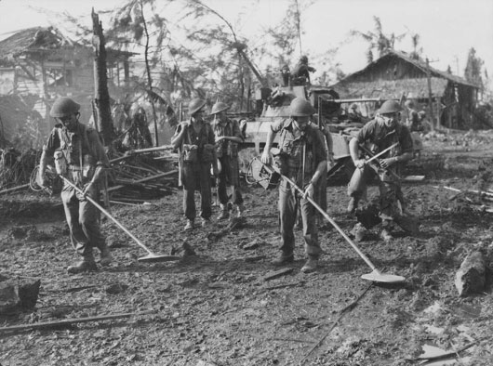
9th September Shire Council Oppose s Daylight Saving. Claiming the t its operations are disadvantageous to the men on the land, a protest has been lodged by Wollondilly Shire Council with the State Government t against the re-introduction of the daylight saving scheme.
Form r Local Boy Wins Military Cross. "Our O.C., Captain Kevin Power, A former local boy, was awarded the Military Cross for gallantry in the New Guinea campaign.”The above message was received by this newspaper in a letter conjointly signed by two Camden infantrymen, Privates Don Atfield and Horace Gander, who served in the Middle East prior to being posted to New Guinea. Don and Horace write in a most appreciative strain concerning the parcels mailed to them by Camden W.V.S. Centre.
11th September Australians capture Salamaua

13th September Private Richard Kelliher VC at Nadzab
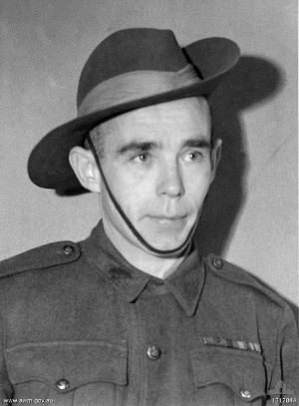

16th September 7th and 9th Divisions enter Lae
16th September CARDS FROM OTHER LADS. A card from Pte. Eric Kelloway, of Camden, to his mother read: "My dear mother—I am a prisoner of war; keeping well. The conditions are satisfactory. Hope you are all well. Best of love to all.—Eric." Private James Boyd sent a card to his wife who resides in Elizabeth-street, Camden. Private Hughie Roberts wrote to his parents, Mr. and Mrs. - C. H. Roberts, of Orangeville: "I am a prisoner of war, but am safe and well." Mrs. T. G. Gall, of Camden, received a card from her husband, Pte. Thomas Gall, who enlisted from Upper Burragorang.' He wrote: "I am P.O.W., came through without a scratch. I am being well treated." (The latter four local soldiers were previously listed as prisoners-of-war.)

22nd September 9th Division Troops land at Scarlet Beach
23rd September Our Lads in New Guinea Victory. Camden and district was well represented by local soldiers in the victorious Lae-Salamaun campaign. Under shocking land and weather conditions our boys helped to defeat the Japanese. All of our local lads appear to have survived the campaign. Anxious relatives now await letters from their loved ones. The boys have been extremely busy and will write at the first possible opportunity. We were all very proud on Tuesday when we read General MacArthur's message relating to the Lae-Salamaun campaign. His words were: "The conduct of the ground troops was splendid beyond words. The Australian contingent included two of the most famous' A.I.F. divisions, who added new lustre to their colours. These are magnificent troops, unsurpassed in the world. "The newer Australian units also coveted themselves, with distinction . . ."

26th September Operation JAYWICK Z Special Forces raid on Singapore Harbour from the Krait
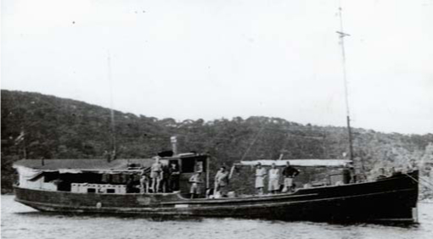
30th September POSTHUMOUS AWARD LATE CORP. HAROL D BUTLER MENTIONE D IN DESPATCHES "His Majesty The King has been graciously pleased to approve of NX55560 Corporal H. P. Butler being Mentioned in Despatches in recognition of gallant and distinguished services in the Middle East during the period 1st May, 1942, to 22nd October 1942.
Corporal Harold Butler was killed in action at El Alamein on October 25, 1942. He had previously served at Tobruk as a stretcher-bearer attached to the 2/13 Infantry Battalion, A.I.F, Harold won the admiration of his officers and comrades for his coolness and efficient work under fire. After Harold's death, his commanding officer wrote: "He was noted for his outstanding courage and indifference to danger."

Ray Herbert Historical Officer Camden RSL Sub Branch

