Historical Officers Report
From the Pages of the Camden Advertiser
March 1944
2nd March Captain Lionel Colin Matthews George Cross at Sandakan, Borneo

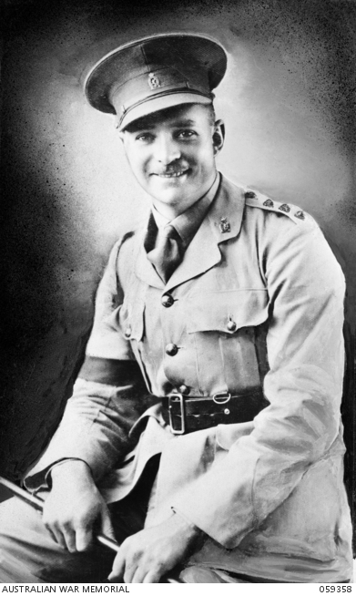
9th March

WOMAN FREED OF WOUNDING CHARGE,

Miss Lillian May Chesham (49), hotel cook, of Camden, has been officially advised that no bill will be filed .against her in connection with a charge of having maliciously wounded Edward John Oswald (53), labourer, of. Camden, on Sunday, January 9.
At a lower court hearing at Camden, Miss Chesham claimed that she
acted in self defence when she slashed Oswald's throat with a razor in
a lonely hut on the banks of the Nepean River. At the time, the woman
alleged, Oswald was attempting to strangle her.
Oswald faces a charge of attempted murder. His trial will take place
at the Central Criminal Court, Darlinghurst, on Monday, March 20.
Miss Chesham will attend the court as a witness.

Hospitality Centre Opens Next Week.

A general invitation is extended to all local residents to attend the official
opening of the Camden Hospitality Centre for Servicemen at 8 p.m. on
Tuesday next, March 14.

Location of the centre is the former billiards room at the Empire Hall
building (entrance by stairway in Oxley-street).
The Y.M.C.A.-A.C.F. has purchased from Mr. Maurice Williams for £175
the complete equipment of the room, including two billiards tables. One
Table will be retained for the use of servicemen.

"When completed the room will be a credit to the town," said Mr. A. Asbee (Y.M.C.A, area officer) when his report was adopted on Friday last
by the local committee.
The officer also reported that the owner of the building, Mr. P. J. Fox,
Had generously offered to provide the premises rent free for the first month.
Camden R.S.S. and A.I. League branch members are to be asked to take charge of the billiards and games
Section at the centre. Every service will be provided entirely free to all servicemen.-

16th March
VALLEY FLIER LOST - FLYING OFFICER WILL
When talking part in an attack on enemy shipping, near Greece, on January 26, an aircraft, piloted by Flying Officer Alex Will, of Burragorang' Valley, was seen to crash into the sea.
This sad news was conveyed to the young R.A.A.F., Officer Parents by the
Wing commander in charge of the R.A.F. squadron to which Alex was attached.
"I circled the position for some time but sighted neither him or his observer,
Nor-any sign of their aircraft, so that there is no doubt whatever but they
Were killed instantaneously," wrote the commanding officer.
"It is highly probable that the aircraft was hit by anti-aircraft fire during
The attack, he continued.
23rd March
FREED FROM CUSTODY - EDWARD OSWALD ACQUITTED
Edward John Oswald (53), of Camden, is a free man. He was acquitted
in the Central Criminal Court on Monday, of a charge of having attempted
To strangle Miss-Lillian May Chesham with intent to murder her, at Camden, on January 9.
Evidence given at the trial was similar to that at the preliminary hearing
At Camden. Oswald, who pleaded not guilty on Monday, said that after he was wounded his mind "went into a blur."'
He was defended by Mr. Gordon Champion, Public Defender.
Miss Chesham and, Mr., Oswald returned to Camden together, on Monday
Night and had their evening meal at the "Capitol," Camden. The couple were obviously relieved of a great strain and chatted happily together as they dined.

30th March
WOUNDED AND PRISONER - FLIGHT-SERGEANT DOUST,
The International Red Cross has learned from a German source
That Flight Sergeant Lyle Doust, a former Camden boy, is wounded
And a prisoner-of-war. Lyle was previously listed as "missing"
When a Halifax aircraft failed to return to its English base on January
22 last after a heavy raid: on Magdeburg, Germany.
Lyle is 23 years of age and the eldest son of Mr. and Mrs. A. (Bert) Doust,
Of Yass. The family resided at Camden for a number of years.
Two other brothers' in" the services are Sergeant Rodney Doust, with the
R.A.A.F. in England, and Trooper Kevin Doust, who served in New Guinea
With the A.I.F.

Bought Native Weapons - At Lonely Outpost.
When setting-up communication points in a lonely part of New Guinea
An A.I.F. officer and sergeant purchased the complete fighting outfit of a
Native tribe.
The officer is Captain Alan Campbell, of Camden, who has sent a number
Of native weapons to his wife. They comprise wickedly designed barbed
Spears, together with an outsize bow and arrows.
The two Australians were the first white, men to have ever entered the
Village. They were guided by a native policeman.
The weapons were purchased as a safety-first measure. Both men were exhausted by jungle travel and badly needed a night's sleep.

Ray Herbert Historical Officer Camden RSL Sub Branch

