Historical Officers Report
From the Pages of the Camden Advertiser
January 1944

6th January Camden Airman Over Germany.
Sergeant Colin Tate, R.A.A.F., former Camden newsagent, was the mid upper-gunner in a Halifax bomber in the great air-raid on Frankfurt on December 20 last. It was his first operational flight over Germany. A Press cable later announced his safe return to an English base.
SERGEANT VICTOR STUCKEY, of Camden, completed his training as en R.A.A.F. navigator in Canada. The temperature was 24 degrees below zero when he penned an aerograph letter to his parents. He was then train travelling through Ontario on his way to New York on leave.
Driver JOHN HOLDSWORTH, who is serving with an A.I.F. field ambulance unit, spent his 19th birthday on active service in New Guinea. During one stage in 1942 his unit climbed for seven days in the Owen Stanley Ranges, At the height of 7,000 feet, the Australians were surrounded by clouds. He returned to the Australian mainland early this year.
13th January
Private SID. BETTS, who is in New Guinea, celebrated his 21st birthday on Monday by applying for a transfer from the Citizen Forces to the A.I.F. Before he joined the army, Sid delivered bread for the Camden bakery firm of Stuckey Bros. He is now a conductor on a transport plane delivering food supplies from the air to his fighting comrades in the more isolated battle fronts of New Guinea.
AIRCRAFTMAN John Day, who recently enlisted in the R.A.A.F., is training for air crew. He is the younger son of Mr. and Mrs. Norman Day, of Camden. His elder brother (William) is also serving in the Air Force.
15th January 9th Division Capture Sio
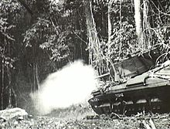
19th January 1st New Guinea Infantry Battalion seize observation Post round Gazelle Peninsula
20th January “Beer Hunters” Sunday Expeditions to Camden.
This newspaper joins in the universal local, protests against the Sunday train-travelling expeditions of beer hunters from the city to Camden. The invading army of booze artist is increasing from week to week as one tells
another "There is plenty beer at Camden." The majority of the 300 drinkers that visited Camden last Sunday arrived by the 3.40p.m.train. They fairly stormed two local hotels which were open to supply the needs of the travelling public. Some departed by the 5.40p.m. Train and a larger number left by the 7.50 from Camden. Most of the latter drinkers were in various stages of intoxication, ranging from ‘swaying' drunk to "staggering", drunk. They included a number of women. Language "blued" the air.

22nd January Australian Forces Capture Sanananda
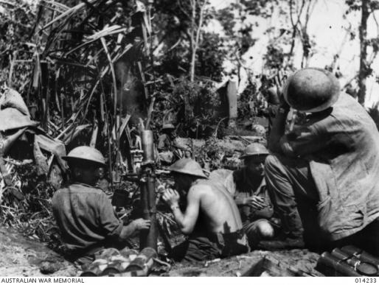
23rd January 7th Division Capture Shaggy Ridge
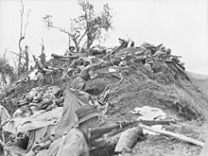
27th January Sunday Beer Hunting Continues at Camden.
The majority of the drinkers on Sunday last arrived at Camden by the 3.40 p.m. train. Three' out of the four local hotels were closed. The other hotel was quickly filled by a milling crowd. A check-up on the collected railway tickets revealed that Auburn held the doubtful pride-of-place in supplying the most passengers for the 'Drunks' Special to Camden. Well represented, too, were Liverpool, Parramatta and Granville'. Fortunately, the crowd decided on an early return journey and more than 300 boarded the 5.40 p.m. train from Camden. Each carriage was packed to a danger capacity with the car platforms over crowded.

Ray Herbert Historical Officer Camden RSL Sub Branch

