Historical Officers Report
From the Pages of the Camden Advertiser
October 1943

2nd October 9th Division Capture Finschhafen
4th October 7th Division Capture Dumpu, Ramu Valley
6th October Heavy night action at Kumawa
7th October MISSING: AIR OPERATION S FLIGHT SERGT. A. A. CRANFIELD Flight Sergeant Astley Cranfield of Camden, a member of the R.A.A.F., is reported missing as a result of air operations on September 22. He is believed to have failed to return to his English base after a very strong force of our bombers had made a highly concentrated attack on the German industrial and communications centre of Hanover. Astley had previously taken part in heavy bombing raids on Milan and on the Ruhr area in Germany during the month of August.
Former Camden Boy Commands Medical Unit. Our congratulations to Lieut. Col. R. F. (Dick) West a former Camden boy. Who now commands an A.I.F. field ambulance unit. Lieut. Col. West, who gained his medical degree in 1937, is a son of Mrs. West and the late Dr. Francis W. West. His father practised, at Camden from 1901 until his death in October, 1932.
12th October RAAF Beaufighters attack Rabaul
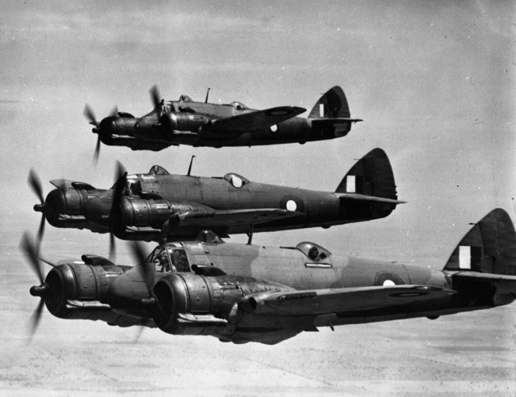
14th October Camden Airmen Arrive in England. Sergeant Air-gunners Colin Tate and Leslie Williamson, of Camden, have cabled their people to announce their safe arrival in England. Before going to the Old Country they enjoyed a short leave period in New York. Before he enlisted in the R.A.A.F., Leslie was employed in the produce department of the firm of F. C. White, man and Sons at Camden. Sergeant Tate stated that he was billeted in a hotel at a famous English holiday resort. He had been issued with his flying kit and was awaiting transfer to an operational-training unit. The R.A.A.F. lads had some difficulty at night in the total black-out, he wrote. "So far the food has been excellent—far better than we received in camp in Australia," added Sergeant Tate.
Camden-Sydney y Ca r Fuel l Test t on Methane Gas. T h e N.R.M.A. reports an n outstanding successful test of methane gas as motor fuel. A three-ton lorry was driven from Sydney to Camden and back, a distance of 85 miles, and there was sufficient gas in reserve to have repeated the trip. After the city traffic was left there was no need to drop from top gear, and on the return trip a grade of 1 in 6.5 was climbed with the engine throttled down so that the vehicle was just moving. There was no stalling. General performance of the gas is reported to be equal in every way to that of high-grade petrol.
21st October 42 Cattle Seize d by Shire Impounding Officer. Newly-appointed Impounding Officer F. D. Dowle probably created a local record by seizing 42 head of straying cattle within a month in the Wollondilly Shire area. Most of the cattle had been released and the prescribed fees paid before they reached the Picton Pound, reported the shire clerk at the October meeting of the council. The remuneration of the impounding officer was fixed at half the deterrent and driving fees, in addition to his wages as a council employee. Two letters of protest from stock owners were received by the council. They have been informed that the officer was carrying out council's instructions following on many complaints relating to straying stock in various parts of the shire.
28th October No items of Interest

Ray Herbert Historical Officer Camden RSL Sub Branch

