CAMDEN R.S.L SUB BRANCH
ANZAC DAY 2024 COMMEMORATION SERVICES

The Camden RSL Sub Branch will be conducting services to commemorate the Anniversary of the Landing at Gallipoli, on behalf of the President and Members of the Camden RSL Sub Branch we cordially invite you to attend ANY OR ALL of the services.

Services to be held:

RSL LifeCare – 25 Estonian Rd, Thirlmere NSW 2572
Tuesday 23rd April, 2024 commencing at 10.30am

Club Menangle at Menangle Raceway – will conduct a short ANZAC Tribute Service at approx. 6.30pm (time to be advised) on Saturday 27th April, 2024

Carrington Centennial Care - ANZAC Day Service will be conducted in the Flagpole Area of Carrington on Wednesday 24th April, 2024 commencing at 10.30am. Everyone is welcome.

Camden RSL Sub Branch Dawn Service will be conducted on Thursday 25th April, 2024 within the Camden Bicentennial Equestrian Park Memorial Site, Cawdor Road, CAMDEN NSW 2570, commencing at approx. 5.15am sharp, Cawdor Road from Camden Sports Club to Barsden Street, will be closed from 4.45am until 7.00am. We request everyone to be seated by 5.00 am.
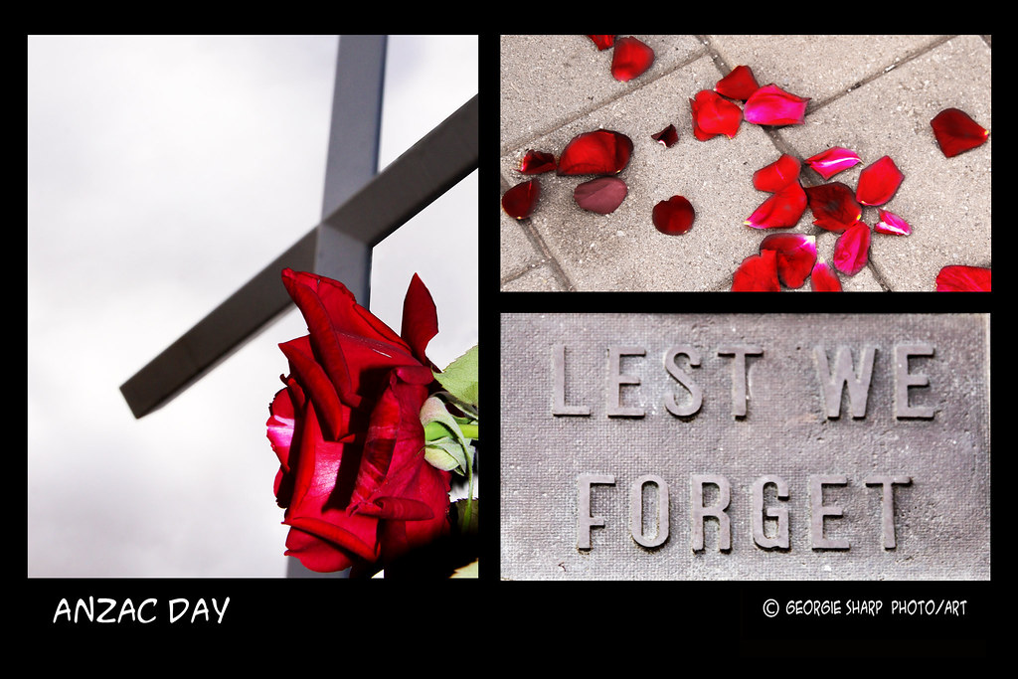

Main ANZAC Day March and Community Service
Marchers will assembly in Elizabeth Street between Mitchell and Elizabeth Streets from 10.00 am with the march commencing at 10.30am, marchers will move from Elizabeth Street, down Arygle Street, follow Cawdor Road to the Camden Bicentennial Equestrian Park.ar
k
Following the completion of the 2024 March into Camden Bicentennial Equestrian Park the 2024 Camden Anzac Day Commemoration Service commences at 11.15 am.

Wreath Laying
Wreath laying is permitted from Schools, Companies, Organisations

We recommend Camden Florist – 02 46 55 8224

Community groups and Individuals during both services prior notice via email would be appreciated.

Any enquiries – Contact: Camden RSL Sub Branch Events Coordinator
Email: CamdenSB@gmail.com

