Historical Officers Report
From the Pages of the Camden Advertiser
July 1943

1st July PRISONERS OF WAR PTE. ERIC KELLOWAY Officially reported last week to be a prisoner-of-war in a Tokyo camp. It was the first news of Eric in 16 months. CPL. HARRY CRITTENDEN Promoted on the field during the battle for Malaya, Corporal Harry Crittenden, NX33947, is how officially reported to be a prisoner of war at Osaka.

FLYING in a Lancaster bomber, Sgt. Wireless Air Gunner Atherton, of Auburn, took part in last week's shattering raid on the Ruhr area. "The bombers ran almost on a railway time-table, with only a few seconds between each plane as it unloaded," he told a Press representative in England after he had returned from the raid.
8th July CAMDEN TOPPED STATE RED CROSS BABY CONTEST. With a final total of £3324/17/- to his credit. Baby Alex Mulley, of Camden Park, gained first place in New South Wales for the largest sum raised irrespective of population in the State-wide Red Cross competition. He will receive an inscribed silver cup.
13th July Mubo cleared of Japanese
15th July New Pests in Cabbages. Until recently a stranger to N.S.W. gardeners, the cabbage butterfly is the latest addition to this State's army of pests. Swarms of these large white butterflies hover over cabbage and cauliflower crops and their larvae produces large green caterpillars. Mr. W. L. Morgan, Senior Entomologist of the Department of Agriculture warns that the pest is capable of causing great losses. Many crops have already been destroyed. Plants should be dusted with arsenate of lead powder, one or two blasts being given to each plant, and care taken to dust the' outside leave as well as the heart.
Our Machine Gunners Fought With Famous 48th. Several local district members of machine-gun battalion fought with the famed 48th Battalion (South Australia) in the great October battle at El Alamein in the Middle East. Within a week outstanding feats of Stark heroism in this fierce engagement won the Victoria Cross for two infantrymen. They were Sergeant Bill Kibby, V.C., and Private Percy Gratwick. V.C. who gave their lives in the performance of incredible tasks to save Units of comrades at exposed danger points. The platoon of .machine-gunners supporting the 48th Battalion included Sergt. A. W. (Gus.) Longhurst, M.M. of Campbelltown; Privates Les Reed, of Camden, who was wounded during the battle; Owen Smart, of Cawdor; "Bill" Fairbairn, a former Camden boy; Frank Colver and Jack Hadden, of Campbelltown and Geoff Boucher, of Campbelltown, who had remained on duty after having suffered a neck wound in an earlier engagement
Good Camp Conditions in Canada. In a letter to his parents at Camden Leading Aircraftman G. (Alex.) Porter praises the excellent camp conditions in Canada. To combat the freezing cold of Canada's winter, the huts are centrally-heated; contain comfortable beds and mattresses, plus pillow and slip, two sheets and three blankets. Showers are installed in the sleeping quarters. The food is also very good. The Y.M.C.A. building has an indoor swimming pool, with the chill taken off the water. As mentioned in an earlier issue, the temperature was 20 degrees below zero when Alex arrived in Canada. Four feet of ice, in places, provided nature's skating rinks for the Australian airmen.
Local Soldier's Find in Wild Gulf Country. A miniature sundial, which registers perfect time, was recently found in the wild Australian Gulf country by Corporal Ronald Hughes, of Oakdale when travelling with an A.I.F. survey unit. "As this part of Australia is still the great unknown the sundial was evidently lost by one of the early explorers. It is a perfect instrument, about the size of a pocket-watch, and will make a great souvenir," he related.
20th July H.M.A.S Hobart torpedoed and damaged off San Cristobel
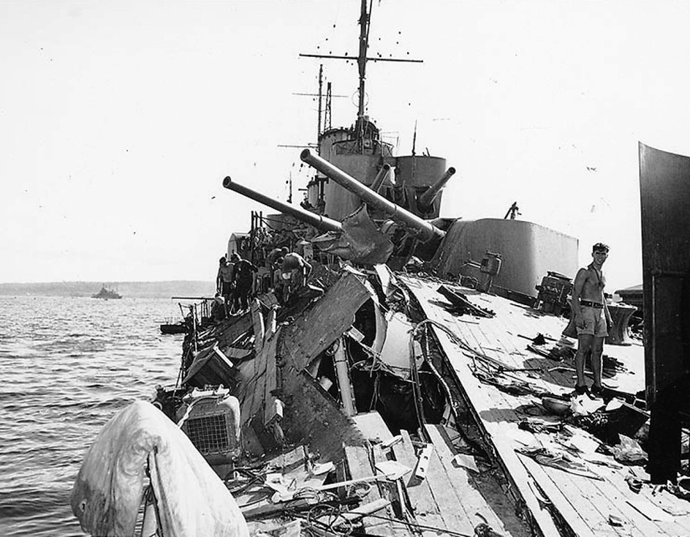
22nd July Navy Footballers at Camden. Camden Soccer Association's "A" team scored a 3 to 1 victory over a British Navy team at Camden Showground on Sunday last. The winner's goal-kickers were Fletcher, G. Byrnes; and E. Clinton. In the early match, Granville State League team, which included four International players, beat Camden Association B by 6 goals to 2; the local scorers were Stannard and M. Taplin. The Camden Association teams were selected from R.A.A.F., Campbelltown and Camden players. Two "Cup" matches will be decided at Camden Showground on Sunday next. The draw is: Camden Magpies v. Camden Waratahs; R.A.A.F. v. Campbelltown A.
29th July Railways "Blot" A Good Record. For the past eight years the "Camden Advertiser" has relied upon the Railways for the fast transit of urgent newspaper copy from Camden to our printers at Parramatta. We received a splendid service until this week when the railways doubly blotted a good record. Two large white envelopes, railed from Camden on Sunday and Monday night, respectively, had failed to reach their Parramatta destination when this edition went to press on Wednesday. Much of our news copy and some twenty advertisements had to be rewritten for this issue. This statement will explain the late delivery of the "Camden Advertiser" this week. We regret that we had no duplicate notes of local football results and a few other news items intended for this issue.

Ray Herbert Historical Officer Camden RSL Sub Branch

