Historical Officers Report
From the Pages of the Camden Advertiser
November 1943
4th November Cawdor Soldier Was a Connecting Link When a Famous A.I.F Division met at Lae. The honour of being the first 7th Division soldier to link with the 9th Division in the historic race to capture Lae, went to 23-year-old Private Len Marden, of Cawdor. Len mentioned the thrilling incident in a letter to his parents, Mr. and Mrs. J. (Lomar) Marden. His recent letters indicate that he had participated in two major actions in New Guinea. After the second engagement he wrote: "We have had another smashing victory over the Japs, Len and a mate was seated on a Japanese plane at Lae when they were photographed by a newsreel cameraman.
11th October LOCAL BROTHERS WIN SIMILAR DECORATION
''Two local brothers have been awarded the Distinguished Service Order for their leadership, and devotion" to duty “in the present war. They are: Brigadier Denzil Macarthur Onslow, DSO." and Lieut.-Col. Edward MacArthur Onslow, D.S.O. Denzil was decorated for his outstanding work in the early engagements against the Italians in the first Libyan campaign. Edward's award was announced last week. When the citation is released it is expected to cover the period from July to early November last year, when he served at Tel Elisa and El Alamein. The youngest of the brothers, Flight Lieut. Andrew Macarthur Onslow was killed in a flying accident at Tamworth on January 18 this year.
SOLDIER AND FLIER. Edward Macarthur Onslow was born at Goulburn; He was educated at Tudor House, Moss Vale; and at King's School, Parramatta. His pastoral activities included the positions of farm manager and acting general manager at Camden Park Estate. Later (in 1938) he founded the Macquarie Grove Flying and Glider School at Camden. For the first 12 months, ended December, 1939, the school secured 42 "A" licenses for pupils. Nearly all the successful candidates subsequently enlisted in the R.A.A.F. Edward Macarthur Onslow was flying instructor at the school. Edward Macarthur Onslow's military career dates back for more than 15 years. He received his commission in the 21st Brigade (militia) Field Artillery in 1928. He later attained the rank of major and became a squadron leader in the 1st (militia) Machine Gun Regiment. He transferred to the A.I.F. in May, 1940, and was appointed company commander in the original 2/2 Machine Gun Battalion. He sailed for overseas in December, 1940. It was in Syria in February, 1942, that he was elevated to the rank of Lieut-Colonel and given the command of his battalion. The battalion, which included a number of lads from the Camden and Campbelltown districts, distinguished itself in the Middle East fighting from July to November 1942, at Tel Elisa and El Alamein. The battalion returned to Australia in March, 1943
12th November Last Japanese Raid on Darwin
17th November Attack on Sattelburg begins
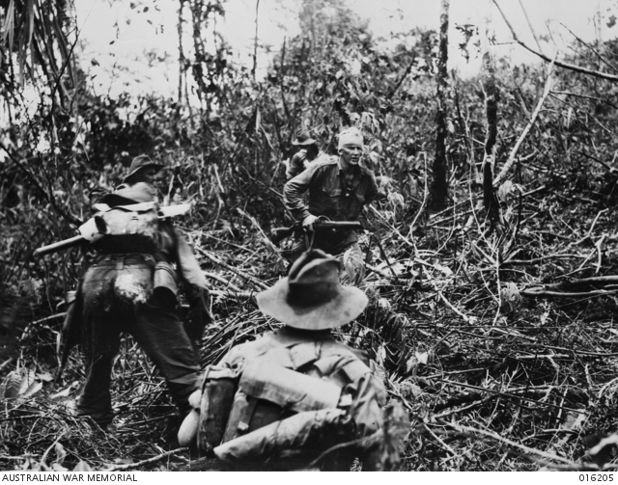
18th November. No items of Interest
24th November Sgt Thomas Currie Derrick VC at Sattelburg
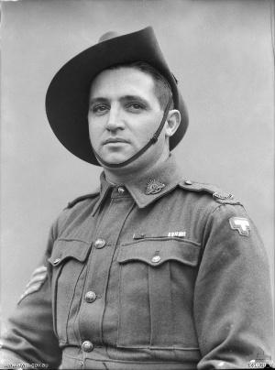
25th November Sattelburg falls to 9th Div

25th November Awarded D.F.C
FLYING OFFICER McINTYRE Flying Officer Kenneth Mclntyre, formerly of Camden, has been awarded die Distinguished Flying Cross for his gallantry in action overseas with the R.A.A.F. Citation states that Mclntyre, as captain of a plane, has completed many successful operations against major targets in Germany. Recently his plane was engaged by enemy fighters, but by skilful tactics Mclntyre was able avoid the fighters and continue his bombing run.

Father Won Military Medal His father served as a sergeant in the 9th Battalion, 1st A.I.F., and was awarded the Military Medal for gallantry and leadership at the battle for Mouquet Farm in August, 1916. Kenneth’s elder brother, W. A. (Jack) Mclntyre, is also serving with the R.A.A.F.

HEROIC ACT The story of two company mates who found their way back through the enemy lines to the Australian position revealed bravery and comradeship of the highest order. One soldier was wounded in the body and unable to walk. The other sustained a hip wound but was able to struggle along. The latter soldier carried his mate a few yards at a time, for six days until they reached the battalion. They were without food during the journey and on one occasion the carrier killed two Japanese. When in the jungle the more seriously wounded man implored his mate to shoot him and try to save himself. The reply was: "If we are to die, we will die together."

26th November 2/23rd Battalion in fighting at Pabu Hill New Guinea

Ray Herbert Historical Officer Camden RSL Sub Branch

